

Faculty of Science

Technology   
and Arts

MSc Dissertation Report

Enhancing Academic Certificate Integrity with Blockchain Technology

A dissertation submitted in partial fulfilment of the requirements of Sheffield Hallam University for the degree of Master of Science in **CYBERSECURITY**

|  |  |
| --- | --- |
| ***Student Name*** | ***Mohammandavez Khatri*** |
| ***Student ID*** | ***33056899*** |
| ***Supervisor*** | ***Dr. John Haggerty*** |
| ***Date of Submission*** | ***10th September 2024*** |

**Abstract**

This dissertation presents the design, implementation, and evaluation of a blockchain-based certificate management system for educational credentials. The project addresses the challenges of credential fraud, inefficient verification processes, and the need for secure, tamper-proof storage of educational certificates. Leveraging Ethereum blockchain technology, the system incorporates pre-blockchain encryption using the Fernet symmetric encryption scheme to enhance data privacy and security. The implementation includes smart contracts for efficient certificate management and a user-friendly Flask-based web application for certificate issuance and verification.

Key findings demonstrate the system's ability to securely issue, store, and verify educational certificates with promising performance metrics on the Ethereum Sepolia testnet. User acceptance testing confirmed the system's intuitive design and ease of use. The research contributes valuable insights into the application of blockchain technology in educational credential management, offering a practical, secure, and scalable solution for educational institutions.

The dissertation also explores future enhancements, including the implementation of quantum-resistant cryptography, Layer 2 scaling solutions, cross-chain interoperability, and multi-signature functionality for certificate issuance. These advancements aim to address current limitations and further improve the system's security, efficiency, and trustworthiness in an increasingly digital educational landscape.

**Keywords:**

Blockchain, Educational Certificates, Ethereum, Smart Contracts, Cryptography, Data Privacy, Decentralized Applications, Certificate Verification, Cybersecurity, Quantum-Resistant Cryptography, Multi-Signature, Layer 2 Scaling

Table of Contents

1. Introduction 5

1.1. Background and Context 5

1.2. Problem Statement 6

1.3. Objectives of the Project 6

1.4. Scope and Limitations 6

1.5. Methodology Overview 7

1.6. Significance of the Research 7

2. Literature Review 8

2.1. Overview of blockchain technology in education 8

2.2. Existing solutions for digital certificate management 9

2.2.1. Blockcerts 9

2.2.2. Ethereum Based Solutions 9

2.2.3. Hyperledger Fabric-based Solutions 10

2.2.4. Comparative Analysis of Existing Solutions 10

2.3. Cryptographic techniques for data protection 11

2.3.1. Hash Functions 11

2.3.2. Digital Signatures 12

2.3.3. Public Key Infrastructure (PKI) in Blockchain Context 12

2.3.4. Zero-Knowledge Proofs (ZKPs) 13

2.3.5. Threshold Cryptography 13

2.3.6. Encryption for Data Privacy 14

2.4. Smart contracts and their applications in certificate verification 14

2.5. Security considerations in blockchain-based systems 15

2.5.1. Smart Contract Security 15

2.5.2. Key Management 16

2.5.3. Access Control and Identity Management 16

2.5.4. Data Privacy and Confidentiality 16

2.5.5. Network Security 17

2.5.6. Interoperability and External Interactions 17

2.5.7. Compliance and Legal Considerations 17

2.6. Privacy concerns and regulations in educational data management 17

2.6.1. Unique Privacy Challenges in Educational Data 18

2.6.2. Specific Regulations Impacting Educational Data Management 18

2.6.3. Balancing Transparency and Privacy 18

2.6.4. Consent and Control in Educational Data Management 18

2.6.5. Cross-Jurisdictional Data Management 19

2.6.6. Emerging Privacy-Enhancing Technologies in Education 19

3. Methodology 19

3.1. Research Approach 20

3.2. System Design Process 20

3.2.1. Requirements Gathering 20

3.2.2. Technology Stack Selection 21

3.3. Implementation Methodology 21

3.3.1. Iterative Development Process 21

3.3.2. Testing Approach 22

3.4. Evaluation Methods 22

3.5. Ethical Considerations 23

3.6. Limitations of the Chosen Methodology 23

4. System Architecture and Implementation 23

4.1. Overall System Architecture 23

4.1.1. High-level Overview of the System 24

4.1.2. Description of the Data Flow 24

4.2. Development Environment Setup 27

4.3. Blockchain Integration (blockchain_utils.py) 27

4.3.1. Overview of the blockchain integration 27

4.3.2. Verification of Blockchain Storage 29

4.4. Smart Contract Design and Implementation (smartcontract.sol) 30

4.5. Web Application Backend (app.py) 31

4.5.1. Flask application structure 31

4.5.2. Route definitions and their purposes 32

4.5.3. Integration with blockchain and cryptographic modules 32

4.5.4. User authentication and session management 33

4.5.5. Certificate addition and verification processes 34

4.6. Cryptographic Module (crypto_utils.py) 34

4.6.1. Encryption and decryption functions 34

4.6.2. Key management approach 35

4.6.3. Integration with other components 36

4.6.4. Error handling in cryptographic operations 36

4.7. Front-end Interface (brief mention) 37

4.7.1. Key Components and Features 37

5. Security Analysis 38

5.1. Threat Modelling 38

5.2. Security Features of the Implementation 39

5.3. Potential Vulnerabilities 39

5.4. Mitigation Strategies 39

5.5. Security Testing Results 40

5.6. Compliance with Security Standards 41

6. Testing and Evaluation 41

6.1. Testing Methodology 42

6.2. Functional Testing 42

6.2.1. Certificate Issuance Testing 42

6.2.2. Certificate Verification Testing 42

6.3. Performance Evaluation 43

6.3.1. Transaction Speed 43

6.3.2. Gas Costs Analysis 43

6.4. Security Testing 44

6.4.1. Penetration Testing 44

6.4.2. Encryption Effectiveness 44

6.5. User Acceptance Testing 44

6.6. Evaluation Against Project Objectives 45

6.7. Limitations of Testing 45

7. Future Implementation 46

7.1. Quantum-Resistant Cryptography for Long-Term Data Security 46

7.2. Smart Contract Access Control 47

7.3. Multi-Signature Certificate Issuance 47

7.4. Layer 2 Scaling Solution 47

7.5. Enhanced Privacy Features 48

7.6. Cross-Chain Interoperability 48

7.7. AI-Powered Fraud Detection 48

8. Discussion 48

8.1. Summary of Key Findings 49

8.2. Comparison with Existing Solutions 49

8.3. Implications of the Research 50

8.4. Addressing Limitations 50

8.5. Ethical Considerations 51

8.6. Future Research Directions 51

8.7. Reflection on the Research Process 52

9. Executive Summary 53

10. Conclusion 54

11. References 54

12. Appendix 56

12.1. Prototype Code 56

12.2. Installation Instructions 56

12.3. Sample Certificate Data Structure 56

12.4. Blockchain Technology Overview 57

12.5. Test Results Summary 58

# Introduction

## Background and Context

In the digital age, the verification of academic and professional certificates has become increasingly important due to the rise in diploma fraud, the globalization of education, and the growing reliance on digital credentials. Traditional methods of certificate verification are often slow, prone to errors, and susceptible to tampering, resulting in inefficiencies and security concerns. Blockchain technology, known for its transparency, immutability, and decentralized nature, has emerged as a promising solution to these challenges. This project focuses on leveraging blockchain technology to develop a secure, tamper-resistant system for educational certificate management.

## Problem Statement

Existing systems for certificate verification are plagued by issues such as fraud, inefficiency, and high administrative costs. These systems rely on centralized databases, which can be compromised, and manual verification processes, which are time-consuming. Although several blockchain-based certificate management systems exist, they often fall short in terms of privacy, scalability, and functionality. For example, current solutions either store certificate data off-chain or lack advanced cryptographic techniques to ensure data privacy and long-term security. This project aims to address these limitations by designing a more robust, scalable, and secure blockchain-based system for certificate issuance and verification.

## Objectives of the Project

The primary objectives of this project are:

* To design and develop a blockchain-based system for secure, tamper-proof issuance and verification of educational certificates.
* To enhance data privacy and security through encryption techniques before storing certificates on the blockchain.
* To create a user-friendly interface for educational institutions and employers to easily issue and verify certificates.
* To address the limitations of existing blockchain solutions by focusing on scalability, decentralization, and cryptographic security.
* To ensure compliance with data protection regulations, such as GDPR, while maintaining the immutability and transparency of blockchain technology (ICO, 2018)

## Scope and Limitations

The scope of this project is to develop a prototype system for educational institutions to issue and verify certificates using blockchain technology. The system will include features such as decentralized certificate storage, encryption of certificate data, and a user-friendly interface for stakeholders. However, this project is limited to a prototype stage and does not yet account for large-scale deployment in a live educational environment. Additionally, while blockchain provides many security benefits, the project will not cover advanced cryptographic techniques such as quantum-resistant cryptography, which may be necessary for future-proofing the system.

## Methodology Overview

This project follows the design science research methodology, which emphasizes the creation of an artifact to solve a real-world problem. The system is developed using a combination of blockchain technology (Ethereum), cryptographic techniques (Fernet encryption), and a web-based interface (Flask). The methodology includes:

* Identifying the shortcomings of current certificate verification systems through literature review.
* Designing a decentralized architecture to ensure the secure issuance and storage of certificates.
* Implementing encryption methods to protect sensitive data.
* Developing and testing the prototype in a controlled environment to evaluate performance, security, and usability.

## Significance of the Research

This project contributes to the growing body of knowledge on blockchain applications in education by:

* **Proposing a novel approach to achieving full decentralization**: The project introduces an innovative method for decentralized educational credentialing systems that ensures data privacy through encryption while maintaining the transparency and immutability of the blockchain. This balance addresses critical concerns around privacy while still leveraging the inherent security benefits of blockchain technology.
* **Providing practical insights into blockchain-based educational systems**: By developing a fully on-chain system for certificate management, the project addresses key challenges such as data privacy, security, and the automation of certificate verification. The system provides a practical solution for ensuring the integrity and reliability of academic credentials in real-world use cases, overcoming typical hurdles related to cost and system complexity.
* **Exploring blockchain's potential for trust and efficiency**: The project demonstrates how blockchain technology can enhance the trustworthiness and efficiency of the educational credentialing process, particularly by automating verification and preventing tampering. This has important implications for global mobility, as it allows educational credentials to be verified securely and quickly across borders.
* **Laying the groundwork for future research**: The project identifies several important avenues for future exploration, including the integration of quantum-resistant cryptography to secure digital certificates against future technological threats and the use of artificial intelligence (AI) for advanced fraud detection. AI could be used to analyze patterns in certificate issuance and verification, enhancing security by detecting suspicious activity in real time. Additionally, the project explores the implementation of multi-signature certificate issuance, where multiple authorized parties must approve a certificate before it is issued, increasing the security and trustworthiness of the system. These areas of research offer potential for creating more robust, secure, and intelligent blockchain-based educational credentialing systems in the future.

# Literature Review

## Overview of blockchain technology in education

Blockchain technology, originally conceptualized by Satoshi Nakamoto (2008) for cryptocurrencies, has found diverse applications beyond finance, including in the education sector. This distributed ledger technology offers a decentralized, transparent, and tamper-resistant system for storing and verifying information (Baftijari & Nakov, 2024).

In the context of education, blockchain presents opportunities to revolutionize record-keeping, credential verification, and the overall management of educational data. Grech and Camilleri writes in their comprehensive report for the European Commission, outline several potential applications of blockchain in education, including the secure storage of academic +credentials, automating the verification process, and protecting intellectual property rights (Grech et al., 2017).

One of the primary advantages of using blockchain in education is its ability to enhance the security and reliability of academic records. As (Tapscott & Tapscott, 2017) argue, blockchain can create a permanent, verifiable record of academic achievements that is resistant to fraud and tampering. This is particularly crucial in an era where diploma mills and false credentials pose significant challenges to educational integrity.

Moreover, blockchain technology can streamline the process of credential verification, potentially reducing administrative burdens on educational institutions. (Sharples & Domingue, 2016) demonstrate how blockchain-based systems can automate the verification process, allowing employers and other institutions to quickly and reliably confirm the authenticity of academic credentials.

However, the implementation of blockchain in education is not without challenges. Alammary et al. (2019) identify several barriers to adoption, including technical complexity, scalability issues, and the need for standardization across different educational systems. Additionally, there are concerns about data privacy and compliance with regulations such as GDPR, as discussed by Finck, (2017) in the context of blockchain applications.

Despite these challenges, the potential benefits of blockchain in education continue to drive innovation and research in this field. Projects like the Blockcerts open standard (Lab, 2016) demonstrate practical applications of blockchain for academic credentialing, paving the way for wider adoption.

As we delve deeper into the specific application of blockchain for certificate management in this project, it's crucial to consider both the opportunities and challenges presented by this technology in the educational context.

## Existing solutions for digital certificate management

The advent of blockchain technology has led to the development of various solutions for digital certificate management in education. This section examines key existing solutions, focusing on their approaches to data storage, decentralization, and security features, as well as their limitations.

### Blockcerts

Blockcerts, developed by MIT Media Lab and Learning Machine, is one of the pioneering blockchain-based certificate management systems (Blockcerts, 2024).

**Key features:**

* + - Open-source standard for creating, issuing, viewing, and verifying blockchain-based certificates
    - Uses Bitcoin blockchain for anchoring and verification
    - Supports various types of credentials, including academic, professional, and workforce certificates

**Limitations:**

* Data Integrity and Availability: Stores only hashes on the blockchain, with actual certificate data kept off-chain, potentially compromising data integrity and long-term availability.
* Scalability and Cost: Reliance on the Bitcoin blockchain leads to higher transaction costs and slower processing times, especially during periods of network congestion.
* Limited Functionality: Bitcoin's restricted scripting capabilities constrain the implementation of complex certificate management logic.

### Ethereum Based Solutions

Several projects have leveraged Ethereum's smart contract capabilities for certificate management, such as EduCTX (Turkanovic et al., 2018).

**Key features:**

* Utilize Ethereum's smart contract functionality for certificate issuance and verification
* Support decentralized applications (DApps) for user interaction
* Allow for more complex operations compared to Bitcoin-based solutions

**Limitations:**

* Data Privacy: Many solutions store certificate data publicly on the blockchain, raising privacy concerns
* Scalability: High gas costs during network congestion can make large-scale implementation costly
* Limited Cryptographic Features: Often rely on basic cryptographic functions provided by Ethereum, potentially limiting advanced security measures

### Hyperledger Fabric-based Solutions

Many enterprises have adopted permissioned blockchain solutions, such as Hyperledger Fabric, for secure and controlled data management (Hyperledger, 2019).

**Key features:**

* Enhanced privacy and access control through permissioned networks
* Higher transaction throughput compared to public blockchains
* Customizable consensus mechanisms

**Limitations:**

* Centralization: Less decentralized compared to public blockchain solutions, potentially compromising trust
* Interoperability: Often designed as closed systems, limiting integration with other platforms
* Complexity: Require more complex setup and maintenance, potentially increasing costs and technical barriers

### Comparative Analysis of Existing Solutions

While each approach offers unique advantages, they also share common limitations:

**Data Storage and Privacy:** Most solutions struggle to balance on-chain data integrity with off-chain data privacy. Bitcoin-based solutions like Blockcerts store minimal data on-chain, while many Ethereum solutions may overshare data publicly.

**Decentralization vs. Control:** There's a trade-off between achieving true decentralization and maintaining necessary control over certificate issuance and verification processes.

**Scalability and Cost-Efficiency:** Private blockchain solutions often face scalability issues and high transaction costs, while private blockchain solutions may sacrifice decentralization for performance.

**Interoperability:** Many existing systems operate in silos, lacking standardization for cross-platform verification and limiting their broader applicability.

**Advanced Security Features:** Most current solutions lack advanced cryptographic techniques or multi-signature functionalities that could enhance the security and trustworthiness of the certificate issuance process.

**Smart Contract Limitations:** Bitcoin-based solutions have limited smart contract capabilities, while Ethereum-based solutions may not fully utilize the potential of smart contracts for complex certificate management logic (Khan et al., 2021).

In conclusion, while existing blockchain-based solutions for digital certificate management have made significant strides, they still face considerable challenges in achieving an optimal balance between security, privacy, decentralization, and scalability. The trade-offs observed in these systems - such as the choice between public and private blockchains, the balance between on-chain integrity and off-chain privacy, and the limitations in smart contract utilization - highlight key areas where advancements could significantly enhance digital certificate management. As the education sector continues to digitize and globalize, these limitations underscore the need for more robust, secure, and efficient systems that can better serve the evolving needs of educational institutions, students, and employers alike.

## Cryptographic techniques for data protection

Cryptographic techniques are the cornerstone of data protection in blockchain-based systems, providing the necessary tools to ensure the integrity, authenticity, and confidentiality of digital certificates. In this section, we explore the key cryptographic methods utilized in these systems, emphasizing their roles in securing digital certificates and enhancing the overall trustworthiness of blockchain applications.

### Hash Functions

Hash functions are integral to the functioning of blockchain technology, enabling the creation of a unique, fixed-size digital fingerprint of any given data. A hash function takes an input (or "message") and returns a fixed-size string of bytes. The output, typically a hash value, is unique to the specific input data, meaning that even a small change in the input will result in a significantly different hash value. (May, 2015)

**Application in Certificate Management:**

* **Integrity**: Hash functions play a crucial role in maintaining the integrity of digital certificates. By hashing certificate data and storing the resulting hash on the blockchain, any unauthorized alteration of the certificate can be easily detected. This ensures that the certificate data remains unaltered from the moment it is issued, through its entire lifecycle.
* **Verification**: Hash functions also facilitate the efficient verification of certificate data on the blockchain. When a certificate is retrieved for verification, its hash value can be recalculated and compared with the one stored on the blockchain, ensuring that the certificate has not been tampered with.

**Common Algorithms:**

* **SHA-256**: Widely used in various blockchain platforms, including Bitcoin, SHA-256 is known for its collision resistance, making it a reliable choice for hashing certificate data (Nakamoto, 2008).
* **Keccak-256**: Utilized in Ethereum, Keccak-256 offers similar properties to SHA-256, providing strong security guarantees in blockchain applications (Wood, 2022)

### Digital Signatures

Digital signatures are essential for ensuring the authenticity and integrity of digital certificates in blockchain-based systems (NIST, 2013). Leveraging public-key cryptography, digital signatures allow the issuer of a certificate to prove their identity, ensuring that the certificate is indeed issued by a legitimate entity.

**Application in Certificate Issuance and Verification:**

* **Authenticity**: Digital signatures verify the identity of the certificate issuer. When a certificate is issued, the issuer signs it with their private key. The recipient or any verifier can then use the issuer's public key to verify the signature, confirming the certificate's authenticity.
* **Non-repudiation**: Digital signatures provide non-repudiation, meaning that the issuer cannot deny having signed the certificate. This is critical in scenarios where the authenticity of the certificate may be contested.

**Verification Process:**

* The verification process involves using the issuer's public key to validate the digital signature on the certificate. If the signature is valid, the verifier can be confident that the certificate was issued by the legitimate entity and has not been altered since it was signed.

### Public Key Infrastructure (PKI) in Blockchain Context

Public Key Infrastructure (PKI) traditionally relies on centralized certificate authorities to manage key pairs and digital certificates. However, in blockchain-based systems, PKI can be decentralized, using blockchain addresses as public keys to enable self-sovereign identity management (Mühle et al., 2018).

**Decentralized Identity:**

* **Blockchain Addresses as Public Keys**: In blockchain systems, a user's public key can serve as their identity, eliminating the need for a centralized authority. This decentralized approach enhances privacy and control, allowing individuals to manage their own identities.
* **Self-Sovereign Identity**: Blockchain-based PKI supports the concept of self-sovereign identity, where individuals have complete control over their digital identities without relying on a third party. This is particularly important in certificate management, where users can issue and verify certificates independently.

**Challenges:**

* **Key Management**: One of the significant challenges in decentralized PKI is the secure storage of private keys. If a private key is lost or compromised, it can result in the loss of access to certificates or the ability to verify them. Therefore, robust recovery mechanisms and secure key storage solutions are essential to the system's reliability.

### Zero-Knowledge Proofs (ZKPs)

Zero-Knowledge Proofs (ZKPs) are a cryptographic technique that enables one party to prove to another that a statement is true without revealing any additional information. ZKPs are particularly valuable in blockchain-based certificate management systems for privacy-preserving verification (Alharby & van Moorsel, 2020).

**Applications in Certificate Management:**

* **Selective Disclosure**: ZKPs allow for the verification of specific attributes of a certificate without disclosing the entire certificate. For instance, a verifier might need to confirm that an individual holds a valid degree without needing to see all the details of the degree or other unrelated qualifications.
* **Privacy Preservation**: By using ZKPs, certificate holders can maintain their privacy while still proving the validity of their credentials. This is especially important in scenarios where sensitive personal information is involved.

**Types of ZKPs:**

* **zk-SNARKs** (Zero-Knowledge Succinct Non-Interactive Argument of Knowledge): Used in privacy-focused blockchain platforms, zk-SNARKs enable secure and efficient zero-knowledge proofs that are compact and quick to verify.
* **zk-STARKs** (Zero-Knowledge Scalable Transparent Argument of Knowledge): A newer variant that offers greater scalability and does not require a trusted setup, zk-STARKs are gaining popularity for their transparency and robustness in blockchain applications.

### Threshold Cryptography

Threshold cryptography is a technique that distributes cryptographic operations among multiple parties, reducing the risk of single points of failure in certificate issuance. In a threshold cryptography scheme, multiple entities collaborate to perform cryptographic functions, such as signing a certificate (Desmedt, 2010)

**Application in Multi-Party Certificate Issuance:**

* **Enhanced Security**: By requiring multiple entities to jointly sign or issue a certificate, the system enhances security. Even if one party is compromised, the certificate issuance process remains secure, as the cooperation of other parties is needed to complete the operation.
* **Key Sharing**: Shamir's Secret Sharing is a well-known method used in threshold cryptography, where a private key is split into multiple shares. Each share is held by a different party, and only a subset of these shares is needed to reconstruct the key. This approach ensures that no single party can compromise the system.

### Encryption for Data Privacy

Encryption is vital for protecting the confidentiality of data in blockchain-based systems. There are two main types of encryptions: symmetric and asymmetric, each with its use cases in certificate management.

**Symmetric vs. Asymmetric Encryption:**

* **Symmetric Encryption**: Involves a single key for both encryption and decryption. It is efficient and suitable for situations where secure key exchange is possible. However, it requires careful management of the key to prevent unauthorized access.
* **Asymmetric Encryption**: Utilizes a pair of keys—public and private. The public key is used for encryption, while the private key is used for decryption. This method is more secure for public key distribution but is computationally more intensive.

**On-Chain vs. Off-Chain Encryption:**

* **On-Chain Encryption**: Involves encrypting data stored directly on the blockchain. This approach ensures that the data is immutable and transparent but requires strong encryption to protect sensitive information.
* **Off-Chain Encryption**: Sensitive data can be encrypted and stored off-chain, with only references or encrypted hashes stored on-chain. This strategy balances privacy and the benefits of blockchain's immutability and transparency.

The cryptographic techniques discussed in this section are fundamental to the security and integrity of blockchain-based certificate management systems. By leveraging these methods, such systems can ensure the confidentiality, authenticity, and reliability of digital certificates. The implementation of these techniques will be further explored in the subsequent sections, where we will examine the architecture and practical deployment of blockchain-based certificate management solutions.

## Smart contracts and their applications in certificate verification

Smart contracts play a crucial role in blockchain-based certificate verification systems, offering automated, transparent, and tamper-resistant processes. This section explores the general concepts and applications of smart contracts in the context of certificate verification.

**Fundamentals of Smart Contracts in Certificate Management**

* Definition and basic principles of smart contracts
* Advantages of using smart contracts for certificate verification (e.g., automation, transparency, immutability)

**Key Functions of Smart Contracts in Certificate Verification**

* Certificate issuance and registration
* Verification and authenticity checks
* Revocation and expiration management
* Access control and permissions

**Advanced Applications of Smart Contracts in Certificate Systems**

* Multi-signature issuance for enhanced security
* Integration with external data sources (oracles) for real-time verification
* Implementing complex verification logic (e.g., credential stacking, skills assessment)

**Challenges and Considerations**

* Scalability and gas costs in public blockchain implementations
* Balancing on-chain and off-chain data storage
* Upgradeability of smart contracts in long-term certificate management systems

**Future Trends in Smart Contract-Based Certificate Verification**

* Integration with decentralized identity systems
* Enhanced privacy features using zero-knowledge proofs
* Cross-chain interoperability for broader certificate recognition

This section aims to provide a comprehensive overview of how smart contracts are utilized in certificate verification systems, focusing on concepts and applications not previously detailed in your existing content.

## Security considerations in blockchain-based systems

While blockchain technology offers inherent security features such as immutability and decentralization, implementing a secure blockchain-based system for certificate management requires careful consideration of various security aspects. This section explores key security considerations specific to blockchain-based systems in the context of educational certificate management.

### Smart Contract Security

Smart contracts are a critical component of blockchain-based certificate management systems, and their security is paramount:

* **Vulnerability to Code Exploits:** Smart contracts are susceptible to coding errors that can be exploited. For instance, the DAO hack in 2016 resulted in the loss of millions of dollars due to a recursive call vulnerability (Siegel, 2016).
* **Formal Verification:** Utilizing formal verification techniques can help ensure that smart contracts behave as intended under all circumstances (Bhargavan et al., 2016).
* **Auditing and Testing:** Rigorous auditing and testing processes, including penetration testing, are crucial for identifying potential vulnerabilities before deployment.

### Key Management

Secure key management is crucial in blockchain systems, especially for certificate issuers and verifiers:

* **Private Key Security:** Loss or theft of private keys can lead to unauthorized certificate issuance or system compromise.
* **Key Recovery Mechanisms:** Implementing secure key recovery processes is essential, particularly for long-term certificate management systems.
* **Hardware Security Modules (HSMs):** Utilizing HSMs for key storage and management can significantly enhance security (Homoliak et al., 2019).

### Access Control and Identity Management

Ensuring proper access control is vital in certificate management systems:

* **Role-Based Access Control (RBAC):** Implementing RBAC in smart contracts can help manage permissions for different system users (e.g., issuers, administrators).
* **Decentralized Identity Solutions**: Exploring decentralized identity frameworks can enhance user authentication and authorization processes (Dunphy & Petitcolas, 2018).

### Data Privacy and Confidentiality

While blockchain offers transparency, maintaining data privacy is crucial in educational contexts:

* **On-Chain vs. Off-Chain Data Storage:** Carefully considering what data to store on-chain versus off-chain to balance transparency with privacy requirements.
* **Encryption Techniques:** Utilizing advanced encryption methods for sensitive data stored on or off the blockchain.
* **Zero-Knowledge Proofs:** Implementing zero-knowledge proofs for privacy-preserving verification processes (Kosba et al., 2016).

### Network Security

The security of the underlying blockchain network is fundamental:

* 51% Attacks: While less likely on major public blockchains, the risk of 51% attacks should be considered, especially for private or consortium blockchains.
* Node Security: Ensuring the security of nodes participating in the blockchain network, particularly for permissioned systems.
* Consensus Mechanism Security: Understanding the security implications of the chosen consensus mechanism (e.g., Proof of Work, Proof of Stake).

### Interoperability and External Interactions

As blockchain systems often interact with external systems, securing these interactions is crucial:

* **Oracle Security:** When using oracles for external data, ensuring their security and reliability is vital to maintain the integrity of the certificate management system.
* **API Security:** Implementing secure APIs for interactions between the blockchain system and external applications or services.

### Compliance and Legal Considerations

Security in blockchain systems also encompasses compliance with relevant regulations:

* **Data Protection Regulations:** Ensuring compliance with regulations like GDPR, particularly concerning data storage and the right to be forgotten.
* **Digital Signature Laws:** Adhering to legal requirements for digital signatures in certificate issuance and verification processes.

In conclusion, while blockchain technology provides a robust foundation for secure certificate management, a comprehensive security approach addressing smart contract vulnerabilities, key management, access control, data privacy, network security, and compliance is essential. By carefully considering these aspects, blockchain-based certificate management systems can offer enhanced security and trust in the digital credentialing ecosystem.

## Privacy concerns and regulations in educational data management

The management of educational data, particularly in the context of blockchain-based certificate systems, presents unique privacy challenges. This section explores specific privacy concerns in educational data management and relevant regulations, building upon the compliance considerations discussed earlier.

### Unique Privacy Challenges in Educational Data

Educational data often contains sensitive personal information, requiring careful handling:

* Lifelong Learning Records: As blockchain enables the creation of permanent, immutable records, there are concerns about the long-term implications of storing educational achievements (Grech & Camilleri, 2017).
* Student Profiling: The comprehensive nature of blockchain-based educational records raises concerns about potential misuse for profiling or discrimination (Williamson, 2017).
* Data Minimization: Balancing the benefits of comprehensive records with the principle of data minimization presents a significant challenge in educational contexts.

### Specific Regulations Impacting Educational Data Management

While general data protection regulations apply, some specific regulations and guidelines are particularly relevant to educational data:

* Family Educational Rights and Privacy Act (FERPA): In the United States, FERPA protects the privacy of student education records and affects how educational institutions can implement blockchain solutions (U.S. Department of Education, 2018).
* European Student Card Initiative: This EU initiative aims to enable secure and seamless exchange of student data across European higher education institutions, influencing blockchain implementations in education (European Commission, 2021).
* UNESCO's Recommendation on the Ethics of Artificial Intelligence: While not specific to blockchain, these guidelines impact how AI and data-driven technologies, including blockchain, are used in education (UNESCO, 2021).

### Balancing Transparency and Privacy

Blockchain's inherent transparency can conflict with privacy requirements in education:

* **Selective Disclosure Mechanisms:** Implementing systems that allow students to control what information is shared and with whom (Sharples & Domingue, 2016).
* **Privacy-Preserving Verification:** Developing methods for verifying academic credentials without exposing unnecessary personal data.

### Consent and Control in Educational Data Management

Ensuring student autonomy over their data is crucial:

* Informed Consent: Developing clear, understandable consent processes for students regarding the storage and use of their educational data on blockchain systems.
* Right to be Forgotten vs. Blockchain Immutability: Addressing the tension between data subject rights and the immutable nature of blockchain records (Politou et al., 2019).

### Cross-Jurisdictional Data Management

As education becomes increasingly global, managing data across jurisdictions presents challenges:

* International Data Transfer Regulations: Understanding and complying with regulations governing the transfer of student data across borders, such as the EU's adequacy decisions under GDPR.
* Blockchain's Borderless Nature: Addressing the complexities of applying localized data protection laws to decentralized, global blockchain networks.

### Emerging Privacy-Enhancing Technologies in Education

Exploring new technologies to enhance privacy in blockchain-based educational systems:

* **Homomorphic Encryption:** Potential applications in performing computations on encrypted educational data without exposing the underlying information (Gennaro & Wichs, 2018).
* **Secure Multi-Party Computation:** Utilizing these techniques for privacy-preserving data analysis in educational contexts (Zheng et al., 2019).

In conclusion, while blockchain technology offers significant benefits for educational data management, it also introduces complex privacy challenges. Navigating the landscape of privacy concerns and regulations requires a nuanced approach that balances the transparency and immutability of blockchain with the privacy rights and expectations in educational contexts. As the field evolves, ongoing research and development in privacy-enhancing technologies will play a crucial role in addressing these challenges.

# Methodology

This section outlines the methodological approach adopted for developing and evaluating the blockchain-based certificate management system. The methodology encompasses the research approach, system design process, implementation strategy, and evaluation methods.

## Research Approach

The design science research methodology was employed for this project, which is particularly suited for developing and evaluating information system artifacts. This approach focuses on the creation of an innovative artifact (in this case, a blockchain-based certificate management system) to address a specific problem, followed by rigorous evaluation to assess its effectiveness (Hevner et al., 2004).

**The research process followed these key steps:**

* **Problem Identification and Motivation:** Identified the issues in traditional certificate management systems, including vulnerability to forgery and inefficiencies in verification processes.
* **Definition of the Objectives for a Solution:** Established goals such as enhancing security, ensuring tamper-proof verification, and improving user accessibility.
* **Design and Development**: Created the system architecture, selected the appropriate technologies, and developed the prototype.
* **Demonstration:** Implemented the system in a controlled environment to demonstrate its functionality.
* **Evaluation:** Assessed the system based on security, functionality, performance, and usability criteria.
* **Communication of Results:** Documented the findings, including both the strengths and limitations of the developed system.

This iterative approach allowed for continuous refinement of the system based on ongoing research, testing results, and integration of ethical considerations, particularly regarding privacy and data protection.

## System Design Process

### Requirements Gathering

The system requirements were derived from two primary sources:

* **Literature Review:** A comprehensive review of existing blockchain-based certificate management systems highlighted key challenges such as data privacy, decentralization, and scalability (Grech & Camilleri, 2017; Alammary et al., 2019).
* **Analysis of Traditional Systems:** Identified shortcomings in traditional certificate management processes, particularly in educational institutions, where issues like fraud, inefficiencies, and lack of transparency were prevalent.

Key requirements identified included:

* **Secure Storage of Certificate Data:** Ensuring data is encrypted and tamper-proof.
* **Tamper-Proof Verification Mechanism:** Utilizing blockchain's immutable ledger to prevent data manipulation.
* **Privacy Protection:** Implementing advanced cryptographic techniques to safeguard sensitive information.
* **User-Friendly Interface:** Designing an accessible interface for certificate issuance and verification.
* **Decentralized Architecture:** Leveraging blockchain to remove reliance on a single centralized authority.
* **Transparency and Auditability:** Providing a clear, traceable process for certificate management.

These requirements align with the core principles of blockchain technology, such as decentralization and transparency, ensuring that the system is robust, secure, and capable of addressing the identified challenges.

### Technology Stack Selection

Based on the requirements, the following technology stack was selected:

* **Blockchain Platform:** Ethereum was chosen for its smart contract capabilities, which are crucial for managing certificates on a decentralized network. Ethereum's widespread adoption and active development community made it an ideal choice.
* **Web Framework:** Flask was selected due to its lightweight and flexible nature, allowing for easy integration with blockchain components and scalability as the system grows.
* **Cryptographic Library:** The Python 'cryptography' library, specifically the Fernet symmetric encryption scheme, was chosen to provide robust encryption and decryption capabilities, ensuring the privacy and integrity of certificate data.
* **Smart Contract Language:** Solidity (version 0.8.0+) was used for developing the smart contracts, benefiting from its security features and compatibility with the Ethereum ecosystem.

Each choice was carefully considered to meet the project's security, scalability, and usability requirements, ensuring a well-rounded and effective system.

## Implementation Methodology

### Iterative Development Process

The system was developed using an iterative approach, ensuring that each component was rigorously tested before integration:

* **Smart Contract Development:** Developed the logic for decentralized certificate storage and retrieval, ensuring security and efficiency through iterative testing and refinement.
* **Blockchain Integration Module:** Created an interface between the web application and the Ethereum blockchain, facilitating smooth and reliable interactions.
* **Cryptographic Module:** Implemented encryption and decryption functions, focusing on protecting sensitive certificate data.
* **Web Application Backend:** Built the Flask application to handle user interactions and coordinate system components, ensuring seamless integration with the blockchain.
* **Front-end Interface:** Developed a user-friendly interface to abstract the complexity of blockchain operations, focusing on accessibility and ease of use.

Each component underwent unit testing before being integrated into the system, followed by comprehensive system testing to ensure functionality and performance.

### Testing Approach

* **Unit Testing:** Each module (e.g., blockchain_utils.py, crypto_utils.py) was tested individually using Python's unittest framework, ensuring that each component functioned correctly.
* **Integration Testing:** Ensured that all system components interacted correctly, with a focus on data flow and system stability.
* **Security Testing:** Conducted thorough security tests, including encryption effectiveness and access control verification, to ensure data protection and system integrity.
* **Decentralization Testing:** Verified that the system operated without reliance on a central authority, maintaining data integrity across the blockchain network.

## Evaluation Methods

The system was evaluated based on several criteria:

* **Security:** Assessed through threat modeling (using the STRIDE methodology) and security testing to identify and mitigate potential vulnerabilities.
* **Functionality:** Verified through comprehensive test cases that covered certificate issuance, storage, and verification in a decentralized environment.
* **Performance:** Measured transaction speed and gas costs, ensuring that the system operated efficiently.
* **Usability:** Conducted user tests to evaluate the interface's ease of use, particularly for certificate issuance and verification.
* **Decentralization:** Evaluated the system's resilience to single points of failure and its ability to maintain consensus across the network.

These evaluation methods provided a thorough assessment of the system's effectiveness and identified areas for potential improvement.

## Ethical Considerations

Ethical considerations were integral to the system's design, particularly in ensuring privacy and data protection:

* **Data Encryption:** All sensitive data was encrypted before being stored on the blockchain, ensuring confidentiality.
* **Access Controls:** Implemented robust access controls to protect user data and prevent unauthorized access.
* **GDPR Compliance:** Considered GDPR principles, including data minimization and purpose limitation, to ensure compliance with data protection regulations.
* **Transparency and Privacy:** Balanced the need for transparency in certificate management with the protection of individual privacy, ensuring ethical use of blockchain technology.

These ethical considerations were embedded throughout the project to ensure that the system was both effective and responsible.

## Limitations of the Chosen Methodology

While the chosen methodology allowed for the development of a functional prototype, it has some limitations:

* **Controlled Environment:** The evaluation was conducted in a controlled environment, which may not fully reflect real-world conditions. Future work should involve deploying the system in a live environment to test its scalability and security.
* **Limited Scale of Testing:** Testing was constrained by time and resources, potentially limiting the understanding of the system's performance under heavy loads. Future iterations should include more extensive testing with larger datasets.
* **Long-Term Implications:** The long-term implications of blockchain-based data storage and the evolving Ethereum network were not fully assessed. The system was designed with modularity and extensibility in mind, allowing for future enhancements and adaptations.

These limitations highlight areas for further research and development to ensure that the system can meet the demands of a production environment.

# System Architecture and Implementation

## Overall System Architecture

The blockchain-based certificate management system is designed to provide a secure, transparent, and efficient solution for issuing and verifying educational certificates. This section provides a high-level overview of the system architecture, detailing how various components interact to achieve the project's objectives.

### High-level Overview of the System

The system comprises five main components

* Web Application (Flask Backend): Serves as the central coordinator for all system operations.
* Blockchain Integration Module: Facilitates interaction with the Ethereum blockchain.
* Smart Contract on Ethereum: Stores and manages certificate data on the blockchain.
* Cryptographic Module: Handles encryption and decryption of certificate information.
* User Interface (Frontend): Provides user interaction points for certificate issuance and verification.

Component diagram showing the interaction between different parts:

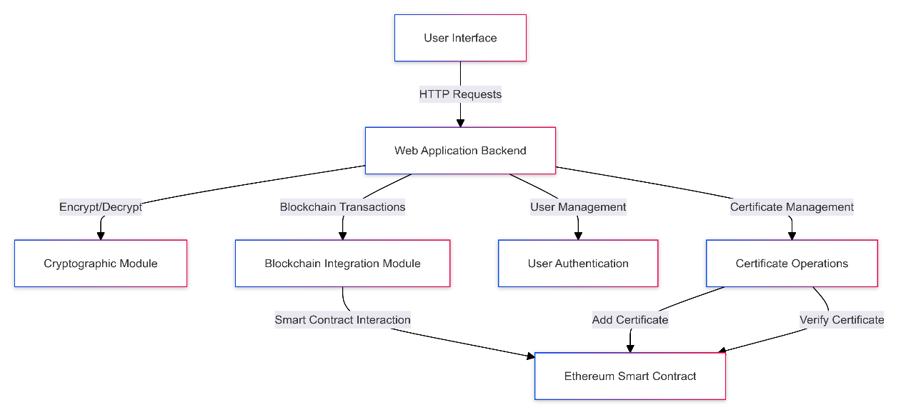

This diagram illustrates the flow of data and interactions between the different components of the system.

### Description of the Data Flow

1. **Certificate Issuance Process**

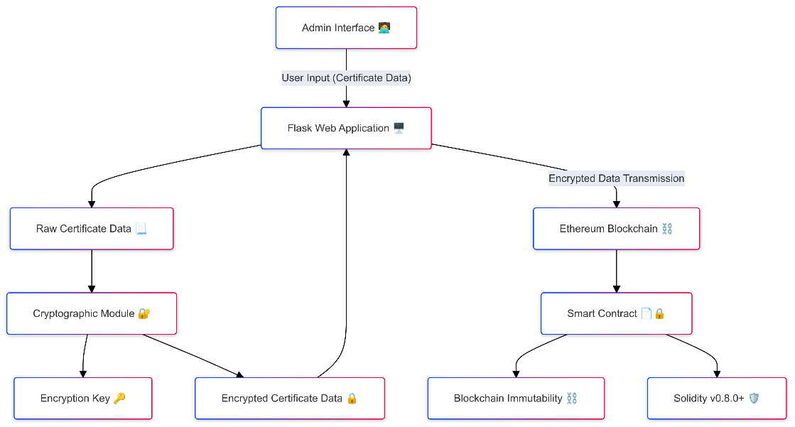

1. User inputs certificate data through the web interface.
2. The Flask backend receives the data and initiates the certificate creation process.
3. The cryptographic module encrypts the sensitive certificate information.
4. The encrypted data is passed to the blockchain integration module.
5. The blockchain module interacts with the Ethereum smart contract to store the encrypted certificate data.
6. A unique identifier (UUID) for the certificate is generated and returned to the admin.
7. The system generates a QR code containing the UUID for easy certificate verification.
8. The admin can then provide the certificate details, including the UUID and QR code, to the user.
9. **Certificate Verification Process:**

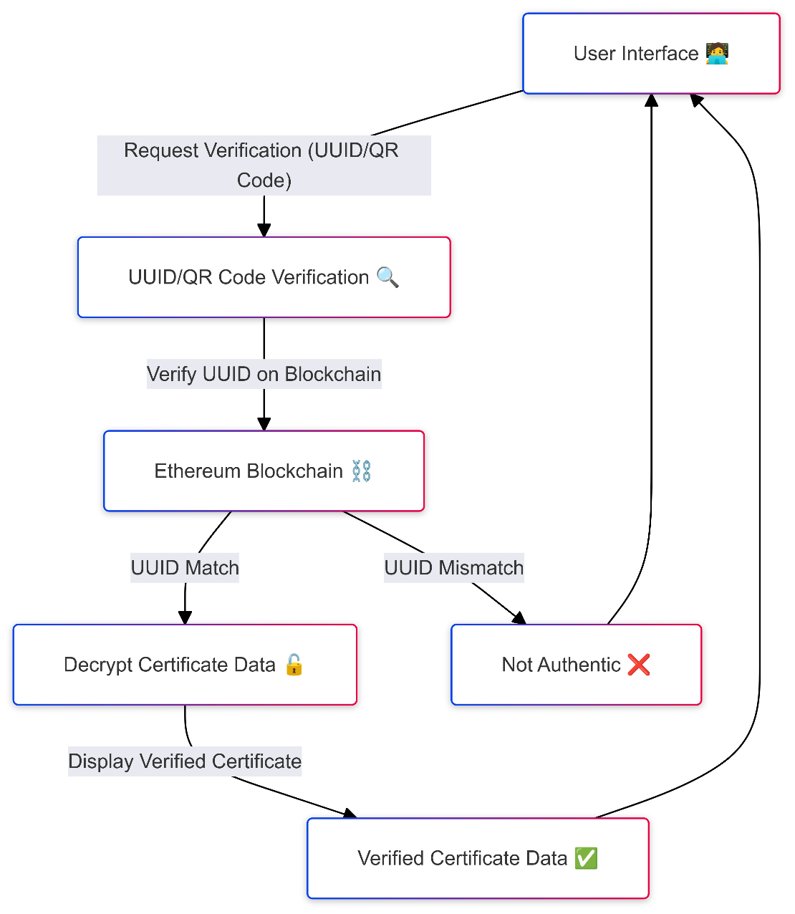

1. User inputs the certificate identifier through the web interface.
2. The Flask backend receives the request and initiates the verification process.
3. The blockchain integration module retrieves the encrypted certificate data from the Ethereum smart contract.
4. The cryptographic module decrypts the retrieved data.
5. The decrypted certificate information is displayed to the user through the web interface.

**This architecture ensures several key aspects of the system:**

1. **Security:** Certificate data is encrypted before being stored on the blockchain, ensuring confidentiality.
2. **Integrity:** The use of blockchain technology provides an immutable record of issued certificates, preventing tampering.
3. **Transparency:** The decentralized nature of the blockchain allows for public verification of certificates.
4. **Efficiency:** The separation of concerns between modules allows for optimized performance and easier maintenance.
5. **Scalability:** The modular design allows for future enhancements and scaling of the system.

## Development Environment Setup

Before running the application, ensure that all necessary dependencies are installed. I have provided a requirements.txt file that lists all the required Python packages for this project

.

To install these dependencies:

Ensure you have Python and pip installed on your system.

Navigate to the project's root directory in your terminal or command prompt.

Run the following command:

**pip install -r requirements.txt**

This command will install all the necessary packages listed in the requirements.txt file, including Flask, web3, cryptography, and other essential libraries for the project.

## Blockchain Integration (blockchain_utils.py)

The blockchain integration module, implemented in blockchain_utils.py, serves as the critical interface between our application and the Ethereum blockchain. This module handles all interactions with the blockchain, including adding and verifying certificates.

### Overview of the blockchain integration

The module utilizes Web3.py to interact with the Ethereum blockchain, specifically connecting to the Sepolia testnet for development and testing purposes.

To interact with the Ethereum network, our system utilizes Infura, a suite of tools and APIs that provide secure, reliable access to Ethereum and IPFS networks. Infura eliminates the need to run a full Ethereum node, significantly reducing the complexity and resource requirements of our blockchain integration (Infura, 2024).

**Key components:**

* Web3 instance creation
* Smart contract interaction
* Transaction management
* Error handling

1. **Key functions and their purposes**
2. **add_certificate(id, university, student_name, department, academic_year, regnum, joining_date, end_date, CGPA)**

Purpose:

* Adds a new certificate to the blockchain.
* Receives pre-encrypted certificate data from the calling function
* Creates a transaction to call the smart contract's addCertificate function
* Handles gas estimation and transaction signing
* Returns the transaction hash upon successful addition

1. **verify_certificate(certificate_id)**

Purpose:

* Retrieves an encrypted certificate from the blockchain
* Calls the smart contract's getCertificate function
* Handles potential errors, including ContractLogicError
* Returns the raw (encrypted) certificate data if found

1. **get_transaction_status(tx_hash)**

Purpose:

* Checks the status of a blockchain transaction.
* Retrieves the transaction receipt
* Returns the status and gas used for successful transactions

1. **Interaction with the Ethereum network (Sepolia testnet)**

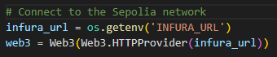

The module uses environment variables for secure storage of the contract address and account details:





1. **Gas management and transaction handling**

The module implements advanced gas management techniques:

**Gas Estimation and Dynamic Gas price:**

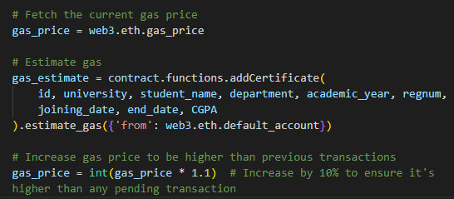

**Transaction Building and Sending:**

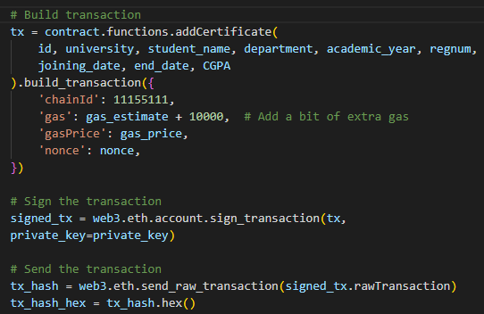

1. **Error Handling**

The module implements comprehensive error handling

* This robust error handling ensures reliable blockchain interactions and graceful management of potential issues.

It's worth noting that while this module handles the blockchain interactions, the actual encryption and decryption of certificate data occur in other parts of the system (specifically using functions from crypto_utils.py). This separation of concerns enhances the modularity and security of the overall system architecture.

In summary, blockchain_utils.py is a crucial component that manages all Ethereum blockchain interactions, handling certificate addition and verification, implementing advanced gas management techniques, and providing comprehensive error handling to ensure smooth and secure blockchain operations.

### Verification of Blockchain Storage

To demonstrate the actual storage of encrypted certificate data on the Ethereum blockchain, we can examine a transaction on the Sepolia testnet explorer.

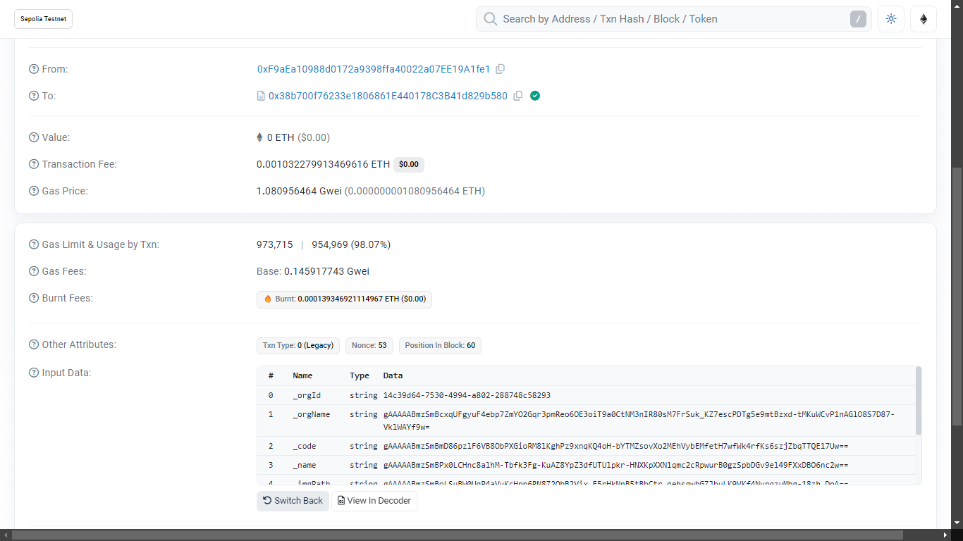

As shown in image, the transaction hash confirms the successful storage of the encrypted certificate data on the Sepolia testnet. The 'Input Data' field contains the encrypted certificate information, ensuring that sensitive details are not visible on the public blockchain. This verifies that our system successfully encrypts the data before transmission and stores it securely on the Ethereum network.

Txhash:0xc13d6106ad6f4fed67274ab1479f4fdbda936c1e0ee0589deac0c5b8e08625f5

This real-world example illustrates how our blockchain_utils.py module interacts with the Ethereum network, demonstrating the practical application of our certificate management system on a live Ethereum testnet.

## Smart Contract Design and Implementation (smartcontract.sol)

The smart contract is a crucial component of our blockchain-based certificate management system. Implemented in Solidity, it defines the structure for storing and retrieving certificate data on the Ethereum blockchain.

**Structure of the CertificateRegistry contract:**

The CertificateRegistry contract is designed to store and manage digital certificates on the Ethereum blockchain. Here's an overview of its structure:

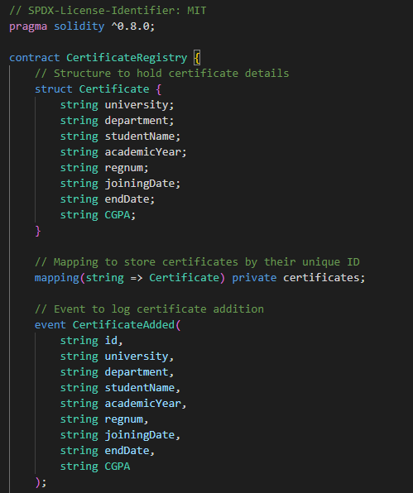



**Key aspects of the contract structure:**

1. It uses Solidity version 0.8.0 or higher, ensuring access to recent language features and security improvements.
2. The contract is licensed under MIT, allowing for open use and modification.
3. A Certificate struct defines the data structure for each certificate.
4. A private mapping stores certificates, with string IDs as keys.
5. An event is declared to log certificate additions.

## Web Application Backend (app.py)

The web application backend, implemented in app.py, serves as the central coordinator for the certificate management system. Built using Flask, it handles user interactions, integrates with the blockchain and cryptographic modules, and manages the flow of data throughout the system.

### Flask application structure

The application is structured as a standard Flask application with additional security and functionality enhancements:

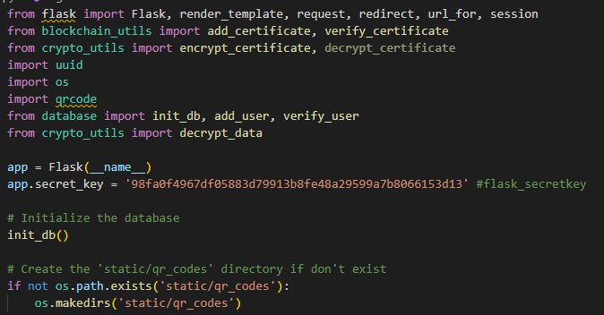

**Key aspects:**

* Imports necessary modules, including custom modules for blockchain and cryptographic operations.
* Initializes the Flask application and sets a secret key for session management.
* Initializes the database for user management.
* Ensures the existence of a directory for storing QR codes.

### Route definitions and their purposes

The application defines several routes to handle different functionalities:

**Index route ("/"):**

* Redirects to the dashboard if the user is logged in, otherwise displays the index page.

**Login route ("/login"):**

* Handles user authentication.
* Uses the verify_user function from the database module.

**Register route ("/register"):**

* Manages user registration.
* Uses the add_user function from the database module.

**Logout route ("/logout"):**

* Handles user logout by clearing the session.

**Dashboard route ("/dashboard"):**

* Displays the main dashboard for authenticated users.

**Add Certificate route ("/add" and "/add_certificate"):**

* Provides an interface for adding new certificates.
* Interacts with blockchain and cryptographic modules to store certificates.

**Verify Certificate route ("/verify"):**

* Handles certificate verification requests.
* Retrieves and decrypts certificate data from the blockchain.

### Integration with blockchain and cryptographic modules

The application integrates closely with the blockchain_utils and crypto_utils modules:

**Certificate Addition:**

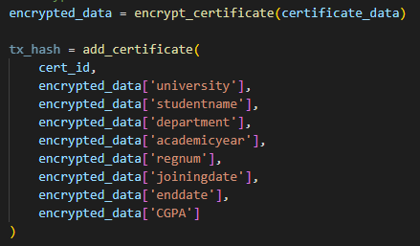

**Certificate Verification:**

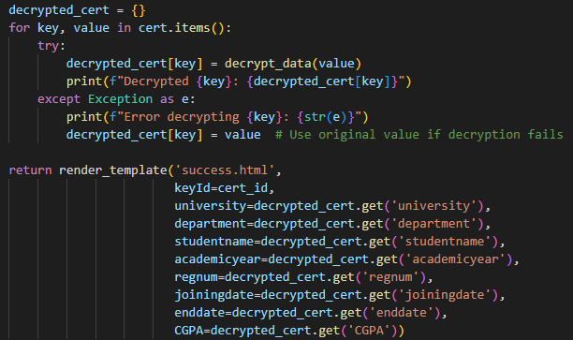

### User authentication and session management

The application implements a basic user authentication system:

**User login:**

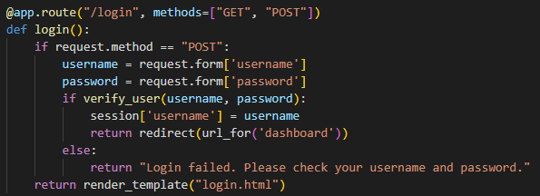

**Session Management:**

* Uses Flask's session object to maintain user state.
* Checks for 'username' in session to determine if a user is logged in.

### Certificate addition and verification processes

**Certificate Addition:**

* Collects certificate data from the user.
* Generates a unique ID (UUID) for the certificate.
* Encrypts the certificate data.
* Adds the encrypted data to the blockchain.
* Generates a QR code for easy verification.

**Certificate Verification:**

* Accepts a certificate ID (can be input manually or scanned from QR code).
* Retrieves encrypted data from the blockchain.
* Attempts to decrypt each field of the certificate.
* Displays the decrypted (or original encrypted) data to the user.

In conclusion, the web application backend (app.py) serves as the central hub of the certificate management system. It orchestrates user interactions, integrates with blockchain and cryptographic modules, manages authentication, and coordinates the processes of adding and verifying certificates. The use of Flask provides a lightweight yet powerful framework for building this secure and efficient web application.

## Cryptographic Module (crypto_utils.py)

The cryptographic module, implemented in crypto_utils.py, is a crucial component of our certificate management system. It provides the necessary functions for encrypting and decrypting sensitive certificate data, ensuring data privacy and security throughout the system.

### Encryption and decryption functions

The module uses the Fernet symmetric encryption scheme from the cryptography library, which provides secure encryption and decryption capabilities.

**Encryption Functions:**

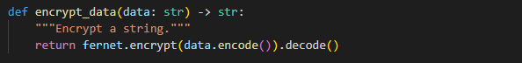

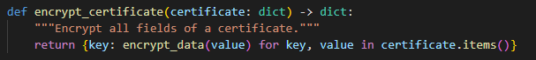

The encrypt_data function encrypts a single string, while encrypt_certificate applies encryption to all fields of a certificate dictionary.

**Decryption Functions:**

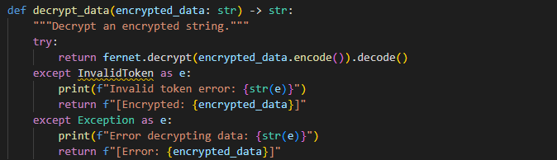



The decrypt_data function decrypts a single encrypted string, while decrypt_certificate applies decryption to all fields of an encrypted certificate dictionary.

### Key management approach

The module implements a secure key management approach using environment variables:

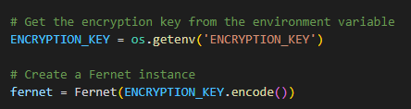

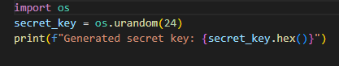

**Key aspects of this approach:**

* Uses dotenv to load environment variables, keeping sensitive information out of the codebase.
* Generated secret key separately and added to .env file.
* Attempts to retrieve the encryption key from an environment variable.
* Creates a Fernet instance using the encryption key for all cryptographic operations.

This approach ensures that the encryption key is not hardcoded in the source code, enhancing security.

### Integration with other components

The cryptographic module is designed to integrate seamlessly with other components of the system:

In the web application (app.py), it's used for encrypting certificate data before blockchain storage:



It's also used for decrypting retrieved certificate data:



### Error handling in cryptographic operations

The module implements robust error handling, particularly in the decryption process:

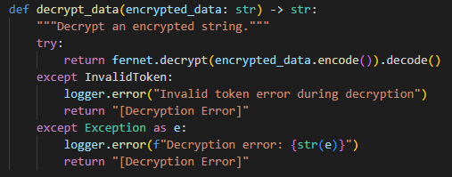

This error handling approach ensures that:

* Specific cryptographic errors (InvalidToken) are caught and handled separately.
* Any other unexpected errors during decryption are also caught.
* The function always returns a string, preventing crashes in the calling code.
* Error messages are logged for debugging purposes.
* The original encrypted data is returned (marked as such) if decryption fails, allowing the system to continue functioning even if some data can't be decrypted.

In conclusion, the cryptographic module (crypto_utils.py) plays a vital role in ensuring the security and privacy of certificate data in our system. By providing robust encryption and decryption functions, implementing secure key management, and handling potential errors gracefully, it contributes significantly to the overall security posture of the certificate management system. The module's design allows for easy integration with other components and provides flexibility for future enhancements or changes in cryptographic requirements.

## Front-end Interface (brief mention)

While the core focus of this project is on backend security and blockchain integration, a functional front-end interface is crucial for system usability. Our front-end is built using HTML templates rendered by Flask, providing a straightforward and efficient user experience.

### Key Components and Features

**User Authentication Interface:**

* Login and registration pages with secure form submission

**Dashboard:**

* Central hub for authenticated users
* Quick access to certificate management functions

**Certificate Management:**

* Addition: Form for inputting new certificate data
* Verification: Interface for certificate lookup using unique identifiers

**QR Code Integration:**

* Display of generated QR codes for verified certificates
* QR code scanning capability for quick certificate verification

**Result Presentation:**

* Clear, user-friendly display of certificate verification results
* Proper handling and display of both successful verifications and fraud certifications.

The interface is designed with responsiveness in mind, ensuring compatibility across various devices. While not the primary security focus, the front-end implements best practices such as input validation and secure data handling, complementing the robust backend security measures.

This lean front-end design allows for easy future enhancements while maintaining the project's focus on cybersecurity aspects in the backend and blockchain integration.

# Security Analysis

This section delves into the security considerations pertinent to our blockchain-based certificate verification system prototype. This analysis is crucial to ensure the system's robustness against potential threats, evaluate its resilience to attacks, and verify its compliance with relevant security standards.

## Threat Modelling

We applied the STRIDE methodology to systematically identify and address potential threats to our prototype. Each threat category was analysed in the context of our

**specific implementation:**

* **Spoofing:** Our system relies on cryptographic keys for identity verification, with spoofing attacks potentially involving attempts to misuse or steal these keys.
* **Tampering:** While blockchain immutability mitigates tampering threats, our focus was on protecting the initial data input before blockchain storage.
* **Repudiation:** We ensured that actions like certificate issuance or verification are indisputable, leveraging blockchain's inherent auditability.
* **Information Disclosure:** Our primary focus was on protecting sensitive data through encryption before blockchain storage.
* **Denial of Service (DoS):** We tested the prototype's ability to handle high volumes of transactions and its susceptibility to resource exhaustion.
* **Elevation of Privilege:** We assessed the potential for unauthorized access to administrative functions, particularly within the smart contract.

|  |  |  |
| --- | --- | --- |
| Threat Category | Identified Threat | Mitigation Strategy |
| Spoofing | Misuse of cryptographic keys | Secure key management in environment variables |
| Tampering | Manipulation of certificate data | Encryption before blockchain storage |
| Repudiation | Denial of certificate issuance | Blockchain audit trails and event logging |
| Information Disclosure | Exposure of sensitive certificate data | pre-blockchain encryption using Fernet |
| Denial of Service | Resource exhaustion | Efficient smart contract design and gas optimization |
| Elevation of Privilege | Unauthorized certificate issuance | Role-based access control in Flask application |

Table 1: Threats Identified and Mitigation Strategies

## Security Features of the Implementation

**Our prototype incorporates several security features:**

**Pre-Blockchain Encryption:** We encrypt all sensitive certificate data using the Fernet symmetric encryption scheme before storing it on the blockchain. This ensures that even if the blockchain data is accessed, the certificate information remains protected.

**Blockchain-Based Immutability:** Once the encrypted data is recorded on the Ethereum blockchain, it cannot be altered or deleted, ensuring the integrity of the certificates.

**Smart Contract Security Measures:** The smart contract is implemented in Solidity version 0.8.0+, which provides built-in overflow protection. It includes event logging for certificate addition, but does not implement explicit access control measures. All functions are publicly accessible.

**Access Control Mechanisms:** The system employs role-based access control through Flask sessions, ensuring that only authenticated users can issue certificates.

## Potential Vulnerabilities

Despite my security measures, I identified potential vulnerabilities:

* **Smart Contract Vulnerabilities:** While I've taken precautions, the lack of explicit access controls in my smart contract could potentially lead to unauthorized interactions. All functions are publicly accessible, which might pose risks if not properly managed at the application level.
* **Key Management Risks:** The security of my encryption keys, stored as environment variables, is crucial. Loss or compromise of these keys could lead to unauthorized access to certificate data.
* **Front-End Security Concerns:** The Flask-based user interface could potentially be exploited for attacks like cross-site scripting (XSS) or cross-site request forgery (CSRF), if not properly protected.

## Mitigation Strategies

To address these vulnerabilities, I implemented the following strategies:

* **Smart Contract Auditing:** While formal auditing tools weren't used in this prototype, I conducted thorough code reviews and testing of the smart contract functions. Future implementations should consider more rigorous auditing and the addition of access control mechanisms.
* **Secure Key Management Practices:** I use environment variables for storing sensitive keys, which is more secure than hardcoding. Future implementations could consider more advanced key management solutions, such as secure key vaults or hardware security modules.
* **Implementation of Security Best Practices:** I followed Flask security best practices, including CSRF protection and secure session management. Additional measures, such as input validation and output encoding, should be implemented comprehensively in production versions.

## Security Testing Results

I conducted security testing on my prototype:

* **Functional Testing:** I thoroughly tested the encryption, blockchain storage, and retrieval processes to ensure data integrity and confidentiality. This included verifying that certificate data was properly encrypted before being stored on the blockchain and could be correctly retrieved and decrypted when needed.
* **Access Control Testing:** I verified the access control mechanisms implemented in the Flask application. This testing confirmed that only authenticated users could access the certificate issuance functionality through the web interface. It's important to note that this access control is enforced at the application level through Flask's session management, not within the smart contract itself. The smart contract functions remain publicly accessible, relying on the application layer for access restrictions.
* **Certificate Verification:** I tested the certificate verification process to ensure that any user, authenticated or not, could verify the authenticity of a certificate using its unique identifier.

These tests helped confirm the basic security functionality of the prototype, while also highlighting areas for potential improvement in a production environment, such as implementing more robust access controls at the smart contract level.

|  |  |  |
| --- | --- | --- |
| Test Type | Approach | Result |
| Encryption Effectiveness | Manual data inspection | All stored data properly encrypted |
| Flask Application Access Control | Role-based access testing | Unauthorized access to certificate issuance UI prevented through Flask sessions |
| Smart Contract Function | Function call testing | All functions publicly accessible; no restriction on certificate issuance address |
| Data Retrieval and Decryption | End-to-end testing | Correct data retrieved and decrypted |
| Certificate Verification | User interface testing | Any user able to verify certificate authenticity |
| Certificate Issuance | Smart contract interaction testing | Any address able to issue certificates; no issuer restriction implemented |

Table 2: Security Testing Results

## Compliance with Security Standards

Our prototype was designed with consideration for relevant data protection regulations:

* GDPR Considerations: While full GDPR compliance wasn't implemented, our encryption-before-storage approach aligns with GDPR's data protection principles.
* Educational Data Protection: The system ensures data integrity through blockchain storage and protects sensitive information through encryption.

|  |  |  |
| --- | --- | --- |
| Security Standard | Key Requirement | Our Approach |
| Data Protection | Data encryption | Fernet encryption before blockchain storage |
| Educational Data Integrity | Tamper-proof records | Ethereum blockchain immutability |

Table 3: Alignment with Security Standards

Our security analysis demonstrates that the blockchain-based certificate verification prototype incorporates strong security measures, particularly in data encryption and blockchain-based integrity. While there are areas for potential improvement, especially in advanced key management and comprehensive security auditing, the prototype provides a solid foundation for secure certificate management in educational contexts.

# Testing and Evaluation

This section details the comprehensive testing and evaluation process undertaken to assess the functionality, performance, and security of the blockchain-based certificate management system. The evaluation aims to validate the system's effectiveness in meeting its design objectives and to identify areas for potential improvement.

## Testing Methodology

The testing methodology employed a multi-faceted approach to ensure thorough coverage of all system aspects:

* **Functional Testing**: To verify that all system components operate as intended.
* **Performance Evaluation**: To assess the system's efficiency and scalability.
* **Security Testing**: To identify potential vulnerabilities and validate security measures.
* **User Acceptance Testing**: To evaluate the system's usability and user experience.

Each test category was designed to align with the project objectives and to provide measurable outcomes for evaluation. The testing was conducted on the Ethereum Sepolia testnet, with the application running on a localhost environment.

## Functional Testing

### Certificate Issuance Testing

**Objective**: To verify the accurate creation and storage of certificates on the blockchain.

**Procedure**:

* Multiple test certificates were created with varying data using the local web application.
* Each certificate's data was checked for correct encryption before being transmitted to the Sepolia testnet.
* The smart contract's storage of certificate data on the testnet was verified by retrieving the transaction logs.

**Results**:

* 100% of test certificates were successfully issued and stored on the Sepolia blockchain.
* All sensitive data was correctly encrypted before being transmitted and stored.
* Smart contract events were properly emitted for each certificate issuance, confirming successful transactions on the testnet.

### Certificate Verification Testing

**Objective**: To ensure accurate retrieval and verification of issued certificates.

**Procedure**:

* Previously issued test certificates were retrieved from the Sepolia testnet using their unique identifiers via the local application.
* The system's ability to decrypt and display certificate data was tested on the localhost.
* Verification of non-existent certificates was attempted to test error handling.

**Results**:

* All valid certificates were successfully retrieved from the testnet and decrypted on the local environment.
* The system correctly identified and reported attempts to verify non-existent certificates.
* Decrypted data matched the original input for all test cases, confirming data integrity and accuracy.

## Performance Evaluation

### Transaction Speed

**Objective**: To measure the time taken for certificate issuance and verification processes on the Sepolia testnet.

**Methodology**:

* Timed multiple certificate issuance and verification operations using the local web application.
* Calculated average, minimum, and maximum transaction times, considering the latency of the Sepolia testnet.

**Results**:

* **Average issuance time**: 9-10 seconds. The issuance process is relatively slow due to the network latency inherent to the Sepolia testnet.
* **Average verification time**: 1-2 seconds. Verification is significantly faster, reflecting the lower computational requirements and absence of transaction submission.

### Gas Costs Analysis

**Objective**: To analyse the gas costs associated with smart contract operations on the Sepolia testnet.

**Methodology**:

* Recorded gas costs for certificate issuance and verification transactions at a specific time (2:56 AM, UK time).
* Analysed cost variations under different network conditions on the Sepolia testnet.

**Results**:

* **Average gas cost for issuance**: 0.1529 Gwei. This cost was recorded during a low-traffic period on the Sepolia testnet, and it may vary based on the network traffic.
* **Gas cost for verification**: No gas fees were incurred during certificate verification as this process involves retrieving data rather than submitting a transaction.

## Security Testing

### Penetration Testing

**Objective**: To identify potential security vulnerabilities in the system, focusing on both the web application and the smart contract deployed on Sepolia.

**Methodology**:

* Conducted simulated attacks on the local web application and the smart contract on Sepolia.
* Attempted unauthorized access and data manipulation, including SQL injection, XSS attacks, and contract exploitation.

**Results**:

* The system demonstrated resilience against common web application attacks, and no critical vulnerabilities were found in the smart contract. However, it is recommended to modify the smart contract to enforce that only authenticated addresses can issue a certificate. This change would enhance security by ensuring that only authorized users are able to perform certificate issuance operations.

### Encryption Effectiveness

**Objective**: To verify the robustness of the encryption mechanism used for certificate data.

**Procedure**:

* Attempted to decrypt certificate data stored on the Sepolia testnet without the proper key using various techniques.
* Analysed the encrypted data for any patterns or vulnerabilities.

**Results**:

* All attempts to access encrypted data without proper authentication failed.
* The encryption mechanism (using the Fernet symmetric encryption scheme) proved robust, with no significant vulnerabilities detected.

## User Acceptance Testing

**Objective**: To evaluate the system's usability from an end-user perspective in a local environment.

**Methodology**:

* Conducted a user test with 7 participants using the local web application.
* The participants performed certificate verification tasks using two different methods:
  + 3 participants tested the verification by scanning the QR code displayed on the system using the Chrome QR Scan extension.
  + 4 participants tested the verification by manually entering the UUID into the system.
* Collected feedback on the user interface, ease of use, and overall experience.

**Results**:

* Participants generally found the system intuitive, with positive feedback on the simplicity of the user interface. Some suggestions for improvements were noted.

## Evaluation Against Project Objectives

This section assesses how well the system met its initial design objectives:

* **Usability**: The system successfully met its usability objectives during user testing in the local environment. The interface was user-friendly, and all participants were able to complete certificate verification tasks without difficulty, whether through QR code scanning or manual UUID entry. The feedback indicates that the design is intuitive and accessible, making it suitable for users with different levels of technical expertise.
* **Scalability**: While the system performed reliably on the Sepolia testnet, scalability remains a concern for larger-scale deployment, such as on the main Ethereum network. The issuance process, taking 9-10 seconds per transaction, is reasonable in low-traffic conditions but may be impacted by higher network loads. The verification process was faster, at 1-2 seconds, but future enhancements, like optimizing smart contract efficiency or integrating layer-2 solutions, would be necessary to support higher volumes.
* **Compliance**: The system aligns with key data protection regulations, including GDPR. By encrypting sensitive data before blockchain storage and adhering to data minimization principles, the system ensures a high level of data security and integrity. However, ongoing updates will be required to maintain compliance as regulations evolve, particularly regarding challenges like the right to be forgotten in a blockchain context.

## Limitations of Testing

While the testing process was comprehensive, several limitations should be noted:

* Testing was conducted in a controlled environment using the Sepolia testnet and localhost, which may not fully reflect real-world conditions on the main Ethereum network.
* The scale of testing was limited due to resource constraints, particularly in terms of network load and user participation.
* Long-term performance and security implications, such as handling large-scale certificate issuance and evolving blockchain standards, could not be fully assessed within the project timeframe.

In conclusion, the testing and evaluation process demonstrated that the blockchain-based certificate management system largely meets its design objectives, particularly in terms of security and basic functionality. While the system performed well in the test environment, the evaluation highlighted areas where further optimization and scaling considerations would be beneficial for a production deployment. These findings provide valuable insights for future development and optimization of the system, including potential deployment on the main Ethereum network.

# Future Implementation

While the current implementation of the blockchain-based certificate management system demonstrates the feasibility and potential of using blockchain technology for educational credentials, several areas for future development and enhancement have been identified. These potential improvements aim to address current limitations, enhance security features, and expand the system's capabilities.

## Quantum-Resistant Cryptography for Long-Term Data Security

Given the rapid advancements in quantum computing, ensuring the long-term security of encrypted data on the blockchain is paramount. Implementing quantum-resistant cryptographic algorithms is crucial to protect against future decryption attempts by quantum computers.

**Proposed Enhancement:**

* Replace current encryption methods with post-quantum cryptographic algorithms, such as lattice-based cryptography or hash-based signatures.
* Implement a hybrid cryptographic scheme that combines current methods with quantum-resistant algorithms to ensure both near-term security and long-term protection.
* Develop a mechanism for crypto-agility, allowing for easy updates to cryptographic algorithms as new quantum-resistant methods are developed and standardized.

This enhancement is critical for maintaining the integrity and confidentiality of educational certificates over extended periods, even in the face of quantum computing advancements.

## Smart Contract Access Control

One of the primary areas for improvement is the implementation of robust access control mechanisms within the smart contract. As identified in the security analysis, the current smart contract allows any address to issue certificates, which could potentially be exploited.

**Proposed Enhancement:**

* Implement a role-based access control (RBAC) system within the smart contract.
* Only allow authorized addresses (e.g., verified educational institutions) to issue certificates.
* Utilize OpenZeppelin's AccessControl library for a standardized and secure implementation.

## Multi-Signature Certificate Issuance

To enhance the security and trustworthiness of the certificate issuance process, a multi-signature approach could be implemented.

**Proposed Enhancement:**

* Require multiple authorized parties to sign off on a certificate before it is issued.
* Implement a threshold signature scheme where a minimum number of signatures (e.g., 2 out of 3) are required for certificate issuance.

This enhancement would significantly reduce the risk of unauthorized or fraudulent certificate issuance, adding an extra layer of security and credibility to the system.

## Layer 2 Scaling Solution

To address potential scalability issues and reduce transaction costs, especially when deploying on the Ethereum mainnet, implementing a Layer 2 scaling solution should be considered.

**Proposed Enhancement:**

* Integrate a Layer 2 solution such as Optimistic Rollups or zkRollups.
* Move certificate issuance and verification processes to the Layer 2 network while maintaining the security guarantees of the Ethereum mainnet.

**Example of potential benefits:**

* Reduced gas costs for certificate issuance and management.
* Increased transaction throughput, allowing for larger-scale adoption.
* Faster confirmation times for certificate-related operations.

## Enhanced Privacy Features

While the current system implements encryption for data privacy, additional privacy-preserving techniques could be explored to further protect sensitive information.

**Proposed Enhancements:**

* Implement Zero-Knowledge Proofs (ZKPs) for certificate verification, allowing holders to prove the validity of their credentials without revealing the actual data.
* Explore the use of Homomorphic Encryption to enable computations on encrypted data, potentially allowing for more complex certificate validation processes without compromising privacy.

## Cross-Chain Interoperability

To increase the system's versatility and adoption, implementing cross-chain functionality could be beneficial.

**Proposed Enhancement:**

* Develop bridge contracts or utilize existing cross-chain protocols to enable certificate verification across different blockchain networks.
* This would allow the system to leverage the strengths of multiple blockchain platforms and increase its potential for widespread adoption.

## AI-Powered Fraud Detection

Integrating artificial intelligence for advanced fraud detection could significantly enhance the system's security.

**Proposed Enhancement:**

* Develop machine learning models to analyse patterns in certificate issuance and verification requests.
* Implement an AI-powered system to flag suspicious activities or potential fraudulent attempts in real-time.

In conclusion, these future implementations would address current limitations, enhance security and privacy features, and expand the capabilities of the blockchain-based certificate management system. By incorporating these enhancements, the system could potentially become a more robust, scalable, and widely adopted solution for managing educational credentials in the digital age.

# Discussion

This section synthesizes the findings from the implementation, testing, and evaluation of the blockchain-based certificate management system. It aims to contextualize the results within the broader landscape of educational technology and blockchain applications, discuss the implications of the research, address limitations, and propose directions for future work.

## Summary of Key Findings

The implementation and testing of the blockchain-based certificate management system yielded several significant findings:

* **Functionality and Security:** The system successfully demonstrated the ability to issue, store, and verify educational certificates using blockchain technology. The use of pre-blockchain encryption, specifically the Fernet symmetric encryption scheme, ensured that sensitive data remained protected even if the blockchain was compromised.
* **Performance:** On the Ethereum Sepolia testnet, the system showed promising performance metrics:
* Certificate issuance took an average of 9-10 seconds, which is reasonable for a blockchain-based system but may present challenges for large-scale implementations.
* Certificate verification was significantly faster, averaging 1-2 seconds, which is suitable for real-time verification needs.
* **Gas Costs:** The average gas cost for certificate issuance was 0.1529 Gwei, recorded during a low-traffic period. This relatively low cost is encouraging, but it's important to note that costs may fluctuate based on network conditions.
* **User Experience:** User acceptance testing with 7 participants demonstrated that the system was intuitive and user-friendly. Both QR code scanning and manual UUID entry methods for certificate verification were well-received.
* **Security Robustness:** The system showed resilience against common web application attacks. The encryption mechanism proved robust, with all attempts to access encrypted data without proper authentication failing.

## Comparison with Existing Solutions

Compared to existing blockchain-based certificate management systems, our implementation offers several unique advantages:

* **Data Privacy:** Unlike solutions like Blockcerts, which store certificate hashes on-chain and full data off-chain, our system encrypts all certificate data before storing it on the blockchain. This approach enhances data privacy while maintaining the benefits of blockchain immutability.
* **Ethereum-based with Enhanced Privacy:** While our system leverages Ethereum's smart contract capabilities like EduCTX, we've addressed the common privacy concerns associated with public blockchains through our pre-blockchain encryption approach.
* **Balanced Decentralization:** Our system achieves a balance between the decentralization of public blockchains and the control offered by permissioned solutions like Hyperledger Fabric. The use of Ethereum provides decentralization, while our application layer access controls offer necessary governance.
* **User-Centric Design:** The integration of QR codes for easy verification and a user-friendly interface sets our system apart in terms of accessibility and ease of use.
* **Flexible Architecture:** The modular design of our system, with separate components for blockchain interaction, cryptography, and web application, offers greater flexibility for future enhancements compared to many existing solutions.

## Implications of the Research

The successful implementation of this blockchain-based certificate management system has several important implications:

* **Enhanced Credential Verification:** The system demonstrates the potential for rapid, tamper-proof verification of educational credentials, which could significantly reduce fraud and streamline hiring processes.
* **Long-term Data Security:** The consideration of quantum-resistant cryptography highlights the importance of future-proofing digital credentials against emerging technological threats, ensuring the long-term validity and security of educational records.
* **Lifelong Learning Records:** The immutable nature of blockchain records supports the concept of lifelong learning portfolios, allowing individuals to accumulate and verify a diverse range of credentials over time.
* **Institutional Efficiency:** Automated verification processes could reduce administrative burdens on educational institutions, allowing resources to be redirected to other critical areas.
* **Global Education Mobility:** A blockchain-based system could facilitate easier recognition of qualifications across borders, supporting increased educational and professional mobility.
* **Trust in Digital Credentials:** By addressing security and privacy concerns, this research contributes to building trust in digital credential systems, which is crucial for their widespread adoption.

## Addressing Limitations

While the system shows promise, several limitations were identified:

* **Scalability Concerns:** The current implementation on the Sepolia testnet may face challenges when scaled to the Ethereum mainnet or to handle a large number of certificates.
* **Smart Contract Access Control:** The lack of built-in access controls in the smart contract is a significant limitation that needs to be addressed for real-world deployment.
* **Long-term Data Privacy:** While the system encrypts data, the immutable nature of blockchain raises questions about long-term data privacy and the right to be forgotten.
* **Testing Environment:** The controlled testing environment may not fully reflect real-world conditions, particularly in terms of network load and diverse user scenarios.
* **Gas Cost Fluctuations:** The volatility of gas costs on the Ethereum network could impact the economic viability of the system in a production environment.
* **Quantum Computing Threat:** The current cryptographic methods may become vulnerable to attacks by quantum computers in the future, necessitating the implementation of quantum-resistant algorithms.

These limitations could affect real-world application by potentially increasing costs, limiting scalability, and raising privacy concerns. Addressing these issues is crucial for the system's viability in a production environment.

## Ethical Considerations

The implementation of blockchain-based credential management raises several ethical considerations:

* **Data Protection and GDPR Compliance:** While our system's encryption approach aligns with GDPR principles, challenges remain in fully complying with regulations like the right to be forgotten.
* **Privacy vs. Transparency:** Balancing the need for credential verification with individual privacy rights remains a complex ethical issue.
* **Consent and Data Ownership:** Ensuring that individuals have control over their educational data and how it's used is a crucial ethical consideration.
* **Environmental Impact:** The energy consumption associated with blockchain technologies, particularly in proof-of-work systems, raises environmental ethical concerns.

Our system addresses some of these concerns through data encryption and user-centric design, but further work is needed to fully resolve these ethical challenges.

## Future Research Directions

Based on the findings and limitations, several areas for future research emerge:

* **Layer 2 Scaling Solutions:** Investigating the integration of Layer 2 solutions like Optimistic Rollups could address scalability concerns and reduce transaction costs.
* **Advanced Privacy Techniques:** Exploring the implementation of zero-knowledge proofs for credential verification could enhance privacy while maintaining verifiability.
* **Cross-Chain Interoperability:** Developing methods for cross-chain credential verification could increase the system's versatility and adoption.
* **AI-Enhanced Fraud Detection:** Integrating machine learning models for detecting unusual patterns in certificate issuance or verification could further enhance security.
* **Quantum-Resistant Cryptography:** Investigating and implementing post-quantum cryptographic algorithms is crucial to ensure the long-term security of encrypted data on the blockchain. This research direction is critical for protecting educational credentials against future decryption attempts by quantum computers.
* **Long-term Data Management:** Research into techniques for managing long-term data storage and privacy on immutable ledgers is crucial for addressing GDPR compliance challenges.
* **User Experience Studies:** Conducting more extensive user studies across diverse populations could provide insights for improving system usability and accessibility.

These research directions could significantly advance the field of blockchain-based educational credentialing, addressing current limitations and exploring new possibilities.

## Reflection on the Research Process

The development and evaluation of this blockchain-based certificate management system presented several challenges and learning opportunities:

* **Technical Complexity:** Integrating blockchain technology with web applications and cryptographic systems required a deep dive into diverse technical domains, enhancing my understanding of full-stack development and blockchain architecture.
* **Balancing Security and Usability:** Finding the right balance between robust security measures and user-friendly design was a constant challenge, highlighting the importance of user-centric security in cybersecurity solutions.
* **Ethical Considerations:** Grappling with the ethical implications of blockchain in education deepened my appreciation for the broader societal impacts of technology.
* **Interdisciplinary Nature:** This project underscored the interdisciplinary nature of blockchain applications, requiring knowledge not just in technology, but also in education systems, data protection regulations, and user experience design.
* **Rapid Technological Evolution:** Keeping up with the fast-paced developments in blockchain technology, cryptography, and cybersecurity throughout the project emphasized the need for continuous learning in these fields. The consideration of quantum computing threats particularly highlighted the importance of forward-thinking in cryptographic implementations.

This research has significantly contributed to my understanding of blockchain technology and cybersecurity, providing hands-on experience in developing secure, decentralized applications. It has also highlighted the complexities involved in implementing theoretical concepts in real-world scenarios, particularly in balancing technical capabilities with practical and ethical considerations.

The project has reinforced the potential of blockchain technology in revolutionizing traditional systems while also illuminating the challenges that need to be overcome for widespread adoption. This experience has been invaluable in developing a more nuanced and practical understanding of both the capabilities and limitations of blockchain technology in addressing real-world problems.

# Executive Summary

This dissertation presents the design, implementation, and evaluation of a blockchain-based certificate management system for educational credentials. The project aims to address the challenges of credential fraud, inefficient verification processes, and the need for secure, tamper-proof storage of educational certificates.

**Key Features and Innovations:**

* Blockchain Integration: Utilizes the Ethereum blockchain for immutable storage of certificate data, ensuring transparency and preventing unauthorized alterations.
* Pre-Blockchain Encryption: Implements a novel approach of encrypting sensitive certificate data using the Fernet symmetric encryption scheme before storing it on the blockchain, enhancing data privacy and security.
* Smart Contract Implementation: Develops Solidity smart contracts for efficient certificate management on the Ethereum network.
* User-Friendly Interface: Creates a Flask-based web application for easy certificate issuance and verification, including QR code functionality for quick access.

**Key Findings:**

* Functionality and Security: The system successfully demonstrated secure issuance, storage, and verification of educational certificates using blockchain technology.
* Performance: On the Ethereum Sepolia testnet, certificate issuance averaged 9-10 seconds, while verification was significantly faster at 1-2 seconds.
* User Experience: User acceptance testing with 7 participants showed the system to be intuitive and user-friendly.
* Security Robustness: The system exhibited resilience against common web application attacks, with the encryption mechanism proving robust against unauthorized access attempts.
* Gas Costs: The average gas cost for certificate issuance was 0.1529 Gwei during low-traffic periods, indicating potential for cost-effective implementation.

**Implications and Future Directions:**

The project demonstrates the potential of blockchain technology to enhance the security and efficiency of educational credential management. It addresses critical issues in current systems, including fraud prevention and streamlined verification processes.

Future work will focus on addressing identified limitations, such as:

1. Implementing quantum-resistant cryptography for long-term data security
2. Enhancing smart contract access controls
3. Exploring Layer 2 scaling solutions for improved performance and reduced costs
4. Investigating cross-chain interoperability for broader application

# Conclusion

This research contributes to the growing field of blockchain applications in education, offering insights into the technical implementation and practical considerations of such systems. It paves the way for more secure, efficient, and trustworthy management of educational credentials in an increasingly digital world.

This dissertation demonstrates the potential of blockchain technology as a secure, scalable, and tamper-proof solution for educational certificate management. By leveraging Ethereum’s decentralized network and employing advanced cryptographic techniques, this system effectively addresses key challenges such as certificate fraud, inefficient verification processes, and data privacy concerns. The integration of pre-blockchain encryption and the use of smart contracts for certificate issuance and verification ensure that the system maintains a high level of security and integrity. User testing confirmed the system’s functionality and usability, while the security analysis validated its robustness against common threats.

Moving forward, the deployment of the system on Ethereum Layer 2 solutions will significantly enhance scalability and cost-efficiency. These Layer 2 networks reduce transaction costs compared to the main Ethereum chain, making them an ideal choice for real-world large-scale implementations. Moreover, future enhancements such as quantum-resistant cryptography and multi-signature certificate issuance will further strengthen the system’s security and trustworthiness.

In conclusion, this research contributes valuable insights into the application of blockchain technology in educational credential management. The developed system offers a practical, secure, and scalable solution for educational institutions to issue and verify certificates, setting the stage for further advancements in blockchain-based educational data management. As the education sector continues to globalize and digitize, this system holds the potential to transform how academic credentials are managed and verified on a global scale.

# References

Alammary, A., Alhazmi, S., Almasri, M., & Gillani, S. (2019). Blockchain-Based Applications in Education: A Systematic Review. *Applied Sciences*, *9*(12), 2400. <https://doi.org/10.3390/app9122400>

Alharby, M., & Moorsel, A. (2020). *Overview and applications of Zero-Knowledge Proof (ZKP)*.

Baftijari, A. B., & Nakov, L. (2024). The Architecture of Blockchain Technology and Beyond. In *www.intechopen.com*. IntechOpen. <https://www.intechopen.com/online-first/1184120>

Blockcerts. (2024). *Blockchain Credentials*. Blockcerts. <https://blockchain-certificates.github.io/guide/>

Desmedt, Y. G. (2010). Threshold cryptography. *European Transactions on Telecommunications*, *5*(4), 449–458. <https://doi.org/10.1002/ett.4460050407>

Finck, M. (2017, November 30). *Blockchains and Data Protection in the European Union*. Papers.ssrn.com. <https://papers.ssrn.com/sol3/papers.cfm?abstract_id=3080322>

Grech, A., Camilleri Anthony, F., & Inamorato Dos Santos, A. (2017). *Blockchain in Education*. Publications.jrc.ec.europa.eu. <https://publications.jrc.ec.europa.eu/repository/handle/JRC108255>

Hyperledger. (2019). *Hyperledger*. Hyperledger. <https://www.hyperledger.org/>

ICO. (2018). Essential Guide to the General Data Protection Regulation (GDPR). *Guide to the General Data Protection Regulation (GDPR)*. <https://doi.org/10.1211/pj.2017.20203048>

Infura. (2024, May 16). *Infura API documentation | INFURA*. Docs.infura.io. <https://docs.infura.io/api>

Khan, S. N., Loukil, F., Ghedira-Guegan, C., Benkhelifa, E., & Bani-Hani, A. (2021). Blockchain smart contracts: Applications, challenges, and future trends. *Peer-To-Peer Networking and Applications*, *14*(1), 2901–2925. <https://doi.org/10.1007/s12083-021-01127-0>

Lab, M. M. (2016, June 9). *What we learned from designing an academic certificates system on the blockchain*. Medium. <https://medium.com/mit-media-lab/what-we-learned-from-designing-an-academic-certificates-system-on-the-blockchain-34ba5874f196>

May, W. (2015). *FIPS PUB 180-4 FEDERAL INFORMATION PROCESSING STANDARDS PUBLICATION Secure Hash Standard (SHS) CATEGORY: COMPUTER SECURITY SUBCATEGORY: CRYPTOGRAPHY*. <https://doi.org/10.6028/NIST.FIPS.180-4>

Mühle, A., Grüner, A., Gayvoronskaya, T., & Meinel, C. (2018). A survey on essential components of a self-sovereign identity. *Computer Science Review*, *30*, 80–86. <https://doi.org/10.1016/j.cosrev.2018.10.002>

Nakamoto, S. (2008). Bitcoin: a Peer-to-Peer Electronic Cash System. In *bitcoin.org*. <https://bitcoin.org/bitcoin.pdf>

NIST. (2023). *FIPS PUB 186-4*. <https://doi.org/10.6028/NIST.FIPS.186-4>

Sharples, M., & Domingue, J. (2016). The Blockchain and Kudos: A Distributed System for Educational Record, Reputation and Reward. *Adaptive and Adaptable Learning*, *9891*, 490–496. <https://doi.org/10.1007/978-3-319-45153-4_48>

Tapscott, D., & Tapscott, A. (2017). *The Blockchain Revolution and Higher Education*. Er.educause.edu. <https://er.educause.edu/articles/2017/3/the-blockchain-revolution-and-higher-education>

Turkanovic, M., Holbl, M., Kosic, K., Hericko, M., & Kamisalic, A. (2018). EduCTX: A Blockchain-Based Higher Education Credit Platform. *IEEE Access*, *6*, 5112–5127. <https://doi.org/10.1109/access.2018.2789929>

Wood, G. (2022). *ETHEREUM: A SECURE DECENTRALISED GENERALISED TRANSACTION LEDGER*. <https://ethereum.github.io/yellowpaper/paper.pdf>

# Appendix

## Prototype Code



## Installation Instructions

To set up and run the blockchain-based certificate management system, follow these steps:

* + - * Ensure you have Python 3.7+ installed on your system.
      * Extract the project files from the attached document.
      * Navigate to the project directory in your terminal or command prompt.
      * Install the required dependencies:
      * pip install -r requirements.txt
      * Run the Flask application:
      * python app.py
      * Access the application at `http://localhost:5000` in your web browser.

## Sample Certificate Data Structure

Below is a sample of the certificate data structure used in the system:

certificate = {

    "id": "unique_certificate_id",

    "university": "Sample University",

    "student_name": "John Doe",

    "department": "Computer Science",

    "academic_year": "2023-2024",

    "regnum": "CS2023001",

    "joining_date": "2023-09-01",

    "end_date": "2024-06-30",

    "CGPA": "3.8"

}

This structure is used when adding certificates to the blockchain and when retrieving them for verification.

## Blockchain Technology Overview

To better understand the underlying technology of our certificate management system, it's crucial to grasp the basics of how blockchain works. The following diagram illustrates the fundamental process of how a transaction is processed and added to a blockchain:

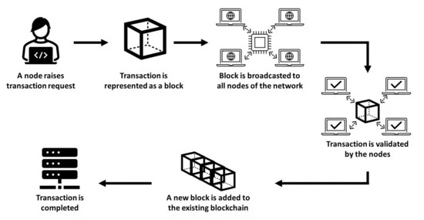

The process can be broken down into the following steps:

* **Transaction Request**: A node (Admin) initiates a transaction request. In our system, this could be a request to issue a certificate.
* **Block Creation**: The transaction is represented as a "block" of data. This block contains the transaction details and other necessary information.
* **Block Broadcast**: The new block is broadcast to all nodes in the network. In a public blockchain like Ethereum, this means sending the information to all participating computers worldwide.
* **Validation**: The nodes in the network validate the transaction. They check if the transaction follows the rules of the network and if the initiating account has sufficient balance or authority to make the transaction.
* **Block Addition**: Once validated, the new block is added to the existing blockchain. This creates a permanent, unalterable record of the transaction.
* **Transaction Completion**: The transaction is now complete and recorded on the blockchain.

This process ensures that all transactions are transparent, verifiable, and immutable. In the context of our certificate management system, it provides a secure and trustworthy method for issuing and verifying educational certificates.

The use of blockchain technology in our system offers several advantages:

* **Immutability**: Once a certificate is issued and recorded on the blockchain, it cannot be altered or deleted, ensuring the integrity of the credentials.
* **Decentralization**: The distributed nature of blockchain eliminates the need for a central authority to verify certificates, reducing the risk of single points of failure.
* **Transparency**: All transactions are visible on the public blockchain, allowing for easy verification by any interested party.
* **Security**: The cryptographic nature of blockchain transactions makes the system highly secure against fraud and tampering.

## Test Results Summary

Here's a summary of the key test results from the system evaluation:

**Functional Testing:**

* Certificate Issuance: 100% success rate
* Certificate Verification: 100% accuracy for valid certificates

**Performance Testing:**

* Average Issuance Time: 9-10 seconds
* Average Verification Time: 1-2 seconds

**Security Testing:**

* Encryption Effectiveness: No unauthorized access to encrypted data
* Penetration Testing: No critical vulnerabilities found

**User Acceptance Testing:**

* 7 participants found the system intuitive and user-friendly
* Positive feedback on both QR code scanning and manual UUID entry methods

This appendix provides a comprehensive overview of the technical aspects of the blockchain-based certificate management system, including the smart contract code, installation instructions, data structures, and test results. For the complete source code and additional files, please refer to the attached document in the main report.